1. Make 6 PC, configure IP address, subnet mask, and default Gateway on all PC.

2. Rename all PC with 3 digit intial your name, my initial name is KRS.

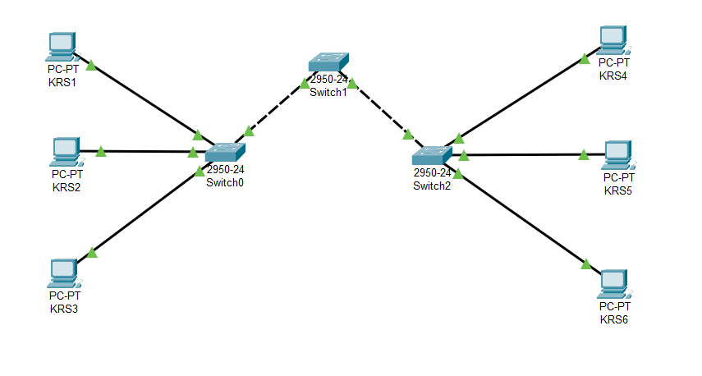Topgrafi Network

Cisco CLI Command

3. Make 3 switch, rename switch with char “S” + initial your name

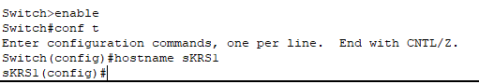Switch 0

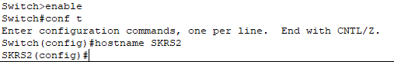Switch 1

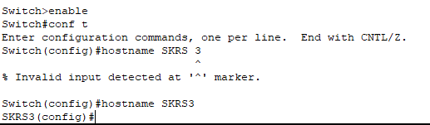Switch 2

4. Configure Switch1 pass is Tom, Switch2 pass is Jerry, and Switch3 pass is Shizuka



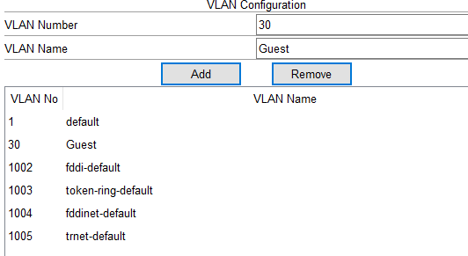5. Configure VLAN on switch on each interface

